**Write sentences**

[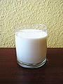](http://commons.wikimedia.org/wiki/File:Mleko.jpg) [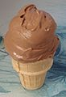](http://commons.wikimedia.org/wiki/File:Chocolate_ice_cream.jpg) [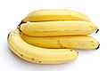](http://commons.wikimedia.org/wiki/File:Bananas_white_background.jpg) [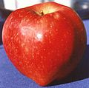](http://commons.wikimedia.org/wiki/File:Red_Delicious.jpg)

☺

I __________________________________________________________________

Susan ______________________________________________________________

We ________________________________________________________________

They _______________________________________________________________

☹

You ___________________________________________________________________

Mum __________________________________________________________________

He ____________________________________________________________________

I ______________________________________________________________________

[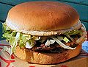](http://commons.wikimedia.org/wiki/File:Hamburger_sandwich.jpg) [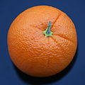](http://commons.wikimedia.org/wiki/File:OrangeFruit.jpg) [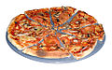](http://commons.wikimedia.org/wiki/File:Pizza-2.jpg)[](http://commons.wikimedia.org/wiki/File:Popcorn_icon.png)

**Write sentences**

spaghetti / likes / he ______________________________________________________.

fish / we / like / don´t ___________________________________________________.

do / like / what / you ____________________________________________________?

like / bread / they ______________________________________________________.

you / do / chips / like____________________________________________________?

dad / milk / like / doesn´t _________________________________________________.

**Write a sentence**

a = ▲ b = ► c = ◄ d = ▼ e = ● f = ○

g = ◘ h = ◙ i = ☺ j = ☻ k = ☼ l = ♠

m = ♣ n = ♥ o =♪ p =♫ q = □ r = ■

s = **\*** t = £ u = **©** v = **↔** w = **↕** x = **∞**

y = **⌂** z = ∑

☺ ♠☺☼ ● ♣☺♠☼ ▲♥▼ ◄●■●▲♠ ○♪■

►■●▲☼○▲**\***£.

_________________________________________________________________________________________.